In this sample code folder, there are 3 demos in all based on CW, IAR and KEIL.

UART0 Baud Rate : 19200.

Notes

1. CW

See read me in kl02-frdm-demo\build\codewarrior.

1. IAR

The base of the sample codes, CW and KEIL code is ported from IAR.

In KL02_GPIO_TSS_Demo, predefine TSS.

1. KEIL

At first, the TSS and the printf can’t be used, some issue are fixed.

1. Printf displays wrong format, no “\r” when print”\n”, root cause and solution :

// in Retarget.c file

int fputc(int c, FILE *f) {

if (c == '\n') { // add this line the issue is fixed

SER_PutChar('\r');

}

//return (sendchar(c));

return (SER_PutChar(c));

}

1. TSS can pass compiling but can’t call TSS1_fCallBack1 function, root cause and solution:

In KEIL project, code starts after reset in startup_xxx.s file from:

Reset_Handler PROC

EXPORT Reset_Handler [WEAK]

IMPORT SystemInit

IMPORT __main

LDR R0, =SystemInit

BLX R0

LDR R0, =__main

BX R0

ENDP

The code is ported from IAR, so at the end of SystemInit()/sysiinit() the main() will be called, but in KEIL this is not ok, main() must be called form the startup_xxx.s. so the solution is to modify below code in start.c :

/* in KEIL, should not call main, but in starup_MKL05Z4.s Reset_Handler */

#ifndef KEIL

/* Jump to main process */

main();

/* No actions to perform after this so wait forever */

while(1);

#endif

1. When click debug button, the code is not downloaded. Root cause and solution;

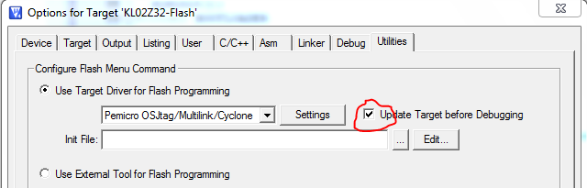

1. Predefine KEIL
2. The project will generate lots of information files, use Delete.bat to delete them

Demo Notes:

1. Freedom_Demo:
2. GPIO_TSS_Demo:
3. Lowpoer_Demo:
4. Bme_demo:

Configure the compiler’s optimization to the highest , or turn out the wrong result.